SIMATS ENGINEERING (SAVEETHA SCHOOL OF ENGINEERING)
Department of Artificial Intelligence and Machine Learning

ASSESSMENT TOOL 1 – Analytical Problem Solving (5 QUESTIONS)

Course Code: | MLA0407 | Course Title: | Deep Learning
 | CO1
 |  |  | Assessment Tool 1 – Analytical problem solving
CO Assessed: |  | Assessment:
 | 35% of CIA
 |  |  | (5 Questions × 10 Marks)
Weightage: |  | Total Marks:
CO1 Statement: | Apply the fundamental concepts of machine learning and neural networks to design and analyze learning algorithms using perceptrons, multilayer perceptrons, forward propagation, backpropagation, gradient descent optimization techniques, and Maximum Likelihood Estimation for solving real-world problems.
Student Name: | Thanmai Reddy | Reg. No.: | 192425372
Section / Batch: |  | Date:

Code of Conduct
I _________________T. Thanmai Reddy/192425372_______ (NAME/ REG NO) certify that this submission is my original work and that I have adhered to the guidelines specified for this assessment. I understand that any violation of academic integrity rules will result in disciplinary action. Signature of the Student: _________________________

QUESTIONS: 5 Total Marks: 50

Annexure A

Analytical Problem Solving Duration: 1hr

Q1.
Design a machine learning solution for predicting customer loan approval using a suitable learning algorithm. Describe the major stages involved in model development, including data preparation, model training, and performance evaluation. (10 marks)

Q2.
Describe the architecture of an Artificial Neural Network (ANN) consisting of input, hidden, and output layers. Illustrate the role of artificial neurons, weights, bias, and activation functions in processing input data to generate predictions. (10 marks)

Q3.
Analyze the working of the Perceptron learning algorithm for solving a binary classification problem. Demonstrate the weight and bias update process for one iteration using a suitable numerical example. (10 marks)

Q4.
Illustrate the forward propagation process in a Multilayer Perceptron (MLP) using a simple neural network with one hidden layer. Compute the output values for the given inputs, weights, biases, and activation function. (10 marks)

Q5.
Demonstrate the Backpropagation algorithm for training a neural network by calculating the output error, propagating the error through hidden layers, and updating the network weights using Gradient Descent. (10 marks)

Q6.
Compare and evaluate Batch Gradient Descent, Stochastic Gradient Descent (SGD), and Mini-Batch Gradient Descent with respect to convergence behavior, computational efficiency, memory requirements, and practical applications in deep learning. (10 marks)

Q7.
Formulate a Maximum Likelihood Estimation (MLE) approach for estimating the parameters of a probability distribution from a given dataset. Interpret the estimated parameters and discuss their significance in machine learning model development. (10 marks)

Q8.
Analyze the impact of the Curse of Dimensionality on machine learning models with respect to training complexity, prediction accuracy, and data sparsity. Propose suitable techniques to overcome these challenges in real-world applications. (10 marks)

Q9.
Design a Multilayer Perceptron (MLP) model for a multiclass image classification problem. Describe the network architecture and explain the role of forward propagation, backpropagation, and Gradient Descent during the training process. (10 marks)

Q10.
Evaluate the importance of learning algorithms in building intelligent machine learning
systems. Compare traditional machine learning approaches with neural network-based learning by considering model complexity, learning capability, and application scenarios. (10 marks)

Rubrics for Calculation

Criteria | Weightage | Level 4 (Exemplary) | Level 3 (Proficient) | Level 2 (Developing) | Level 1 (Beginning)
Technical  Content  Accuracy | 30 | Highly accurate, indepth, and  insightful technical explanation | Technically correct content  with adequate depth and clarity | Basic concepts presented with limited accuracy and depth | Content contains major technical  errors; concepts poorly understood
Problem Identification | 25 | Problem rigorously analyzed using  appropriate and advanced methods | Problem clearly defined with a logical  engineering approach | Problem identified but analysis or  methodology is weak | Problem statement  unclear or  incorrect; no logical approach
Use of Tools | 20 | Advanced tools, wellanalyzed data, and highly effective visuals | Appropriate tools and data used effectively with clear visuals | Limited use of tools and basic data  interpretation | Minimal or incorrect use of  tools and data; poor visuals
Communication | 15 | Highly engaging, confident, and  audience-focused delivery | Clear, organized, and professional communication | Understandable but lacks clarity, structure, or confidence | Poor organization,  unclear speech, ineffective slides
Professionalism | 10 | Exemplary professionalism, leadership, and ethical awareness | Professional conduct with effective team collaboration | Basic professionalism; uneven team participation | Lacks professionalism; minimal  contribution or ethical  awareness

Faculty In-charge | Course Coordinator | Program Director
Signature: _______________
Date: ___________________
Signature: _______________ | Signature: _______________
Date: ___________________ | Date: ___________________

Name: - T. Thanmai Reddy Course code: - MLA0202
Reh no: - 192425372 Course Name: - Deep Learning

Q1. Design a machine learning solution for predicting customer loan approval using a suitable learning algorithm. Describe the major stages involved in model development, including data preparation, model training, and performance evaluation.
Program: -
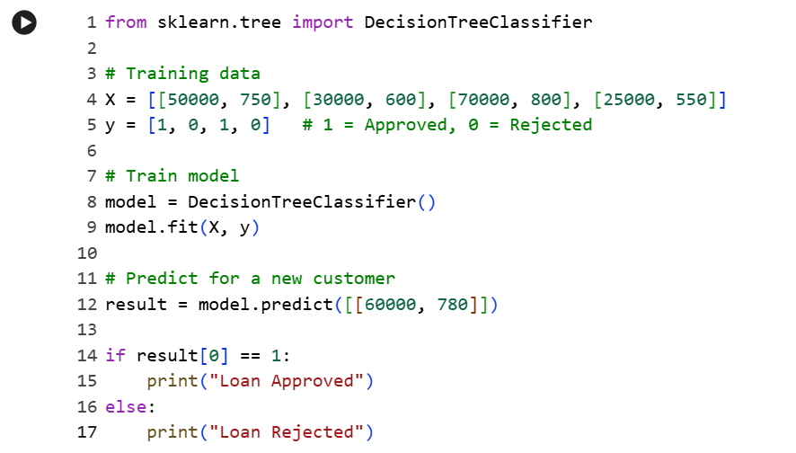
Output: -


Predicted Loan Status = Approved
Result: -
The machine learning model successfully predicts that the customer's loan is approved.

Q2. Describe the architecture of an Artificial Neural Network (ANN) consisting of input, hidden, and output layers. Illustrate the role of artificial neurons, weights, bias, and activation functions in processing input data to generate predictions.
Program: -
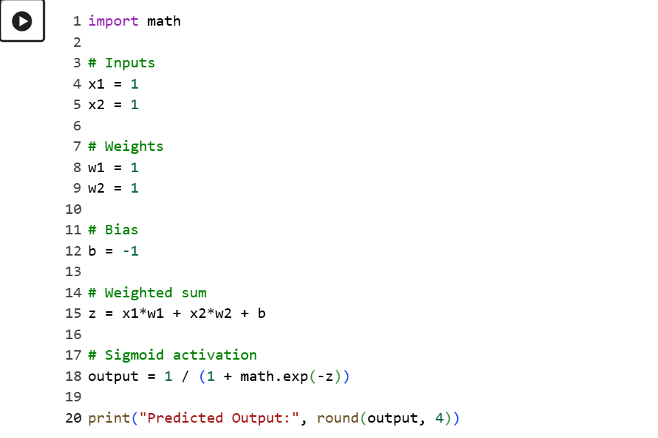
Output: -
Result: -
The Artificial Neural Network successfully generates the predicted output using the sigmoid activation function

Q3. Analyse the working of the Perceptron learning algorithm for solving a binary classification problem. Demonstrate the weight and bias update process for one iteration using a suitable numerical example.
Program: -
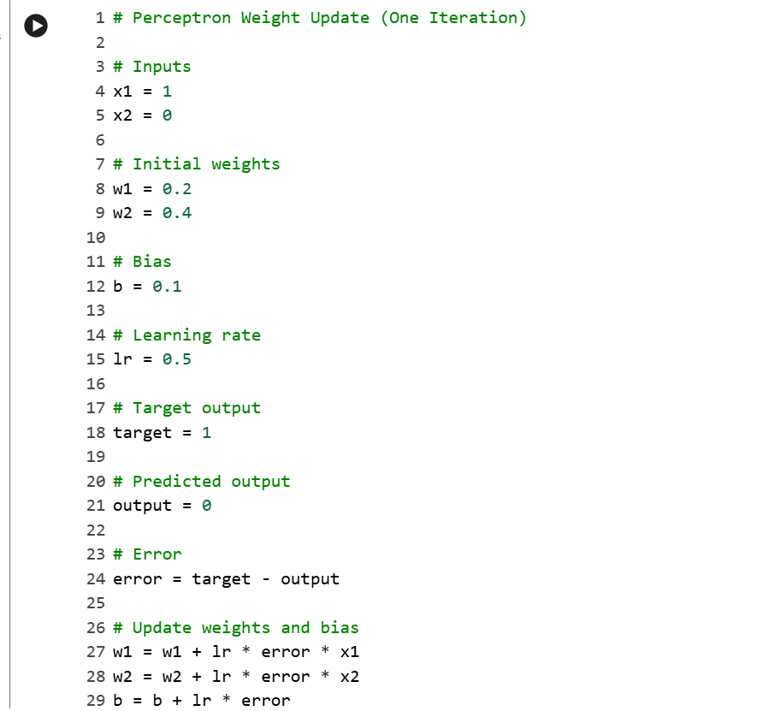
Output: -

Result: -
The perceptron successfully updates the weights and bias after one training iteration.

Q4. Illustrate the forward propagation process in a Multilayer Perceptron (MLP) using a simple neural network with one hidden layer. Compute the output values for the given inputs, weights, biases, and activation function.
Program: -
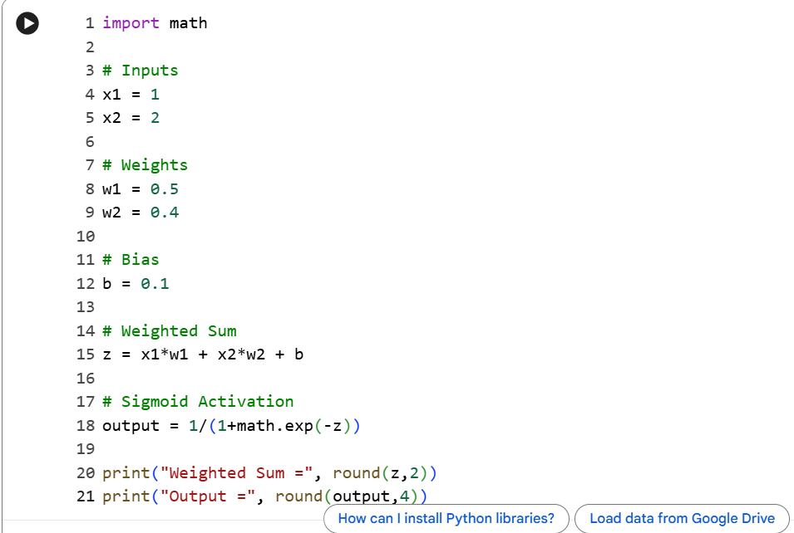
Output: -

Result: -
The perceptron successfully updates the weights and bias after one training iteration.

Q5. Demonstrate the Backpropagation algorithm for training a neural network by calculating the output error, propagating the error through hidden layers, and updating the network weights using Gradient Descent.
Program: -
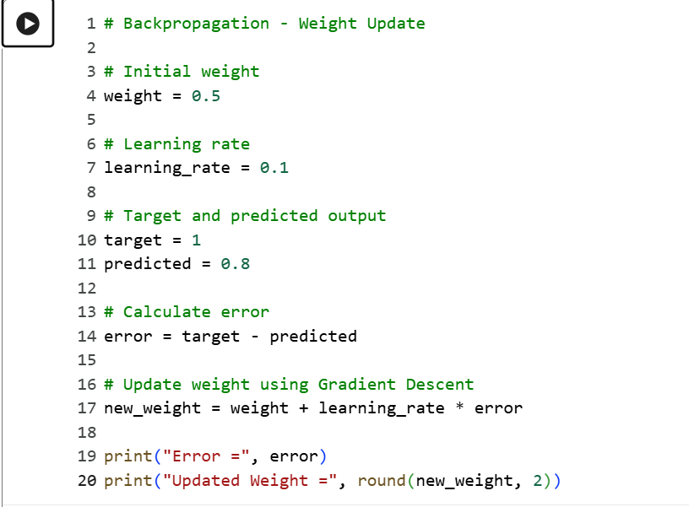
Output: -

Result: -
The Backpropagation algorithm updates the network weight using the calculated error and Gradient Descent.

